ASSESMENT-4


K. R. MANGALAM UNIVERSITY BTech (AI & ML) SOET
(School of Engineering and Technology)

NAME: Anurag Pandey
ROLL NO: 2301730094
COURSE: Computer Networks Course Code: (ENCS352)
K. R. MANGALAM UNIVERSITY, SOHNA ROAD GURUGRAM, HARYANA

Experiment Objectives:

Configure and test a Domain Name System (DNS) Server to resolve domain names into IP addresses using simulation or real/virtual environment.

Learning Outcomes

• Understand working of DNS (name resolution process)
• Configure DNS server using Cisco Packet Tracer
• Verify DNS resolution using commands
• Analyze DNS query-response mechanism

Task :

Basic DNS Server Setup (Cisco Packet Tracer)
1. Launch Cisco Packet Tracer
2. Create a new network topology
3. Add devices:
• 1 Server (DNS Server)
• 2–3 PCs • Switch
4. Connect devices using copper cables
5. Assign IP addresses:
• DNS Server (e.g., 192.168.1.2)
• PCs (same network)
6. Configure DNS Server: • Click Server → Services → DNS
• Turn DNS ON
• Add records:
- www.example.com → 192.168.1.2
- www.google.com → 8.8.8.8 7. Configure PCs:
• Set DNS IP as server IP (192.168.1.2)
8. Verify:
• Use command prompt:
9. ping www.example.com
• Use web browser simulation

Github link: https://github.com/Anurag637/Computer-Network
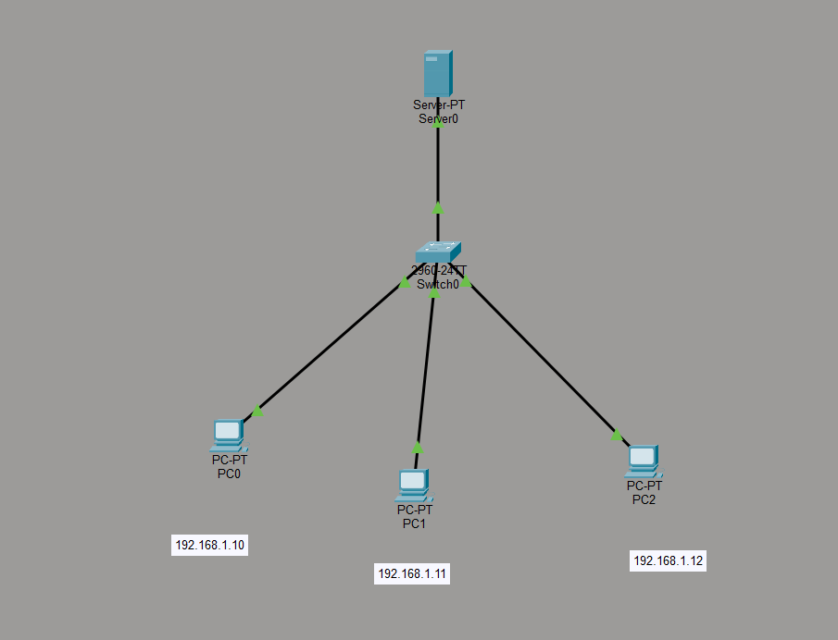
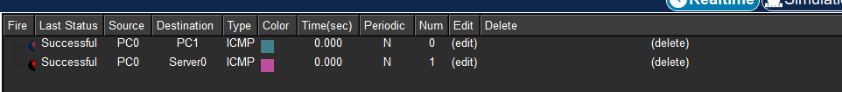
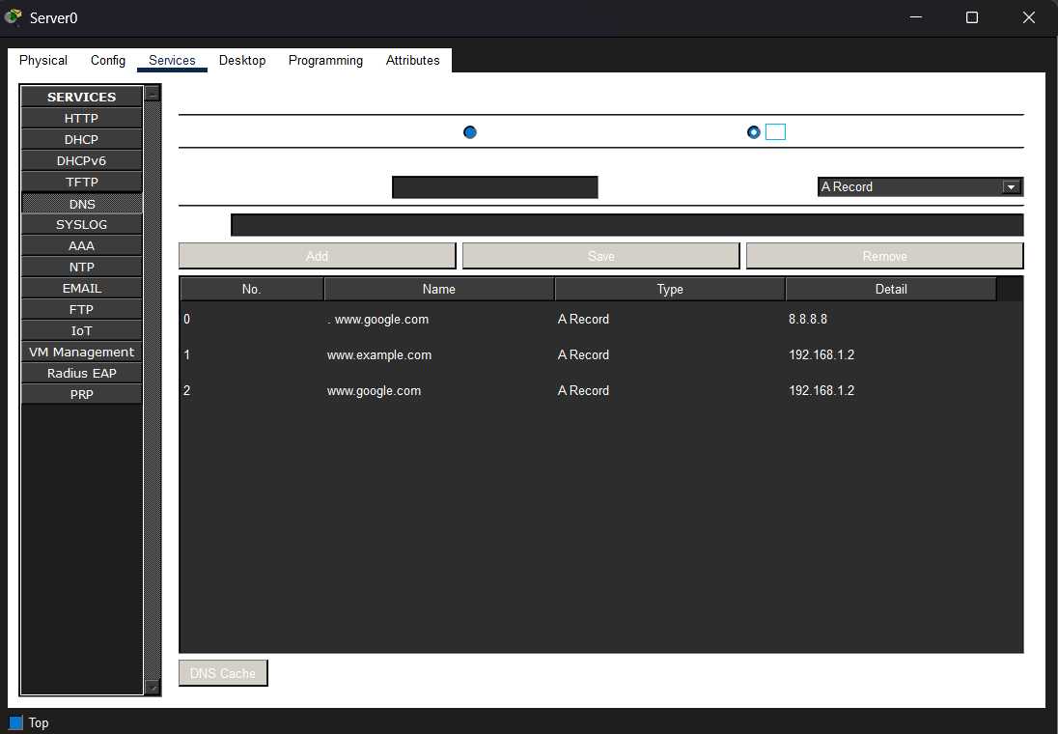
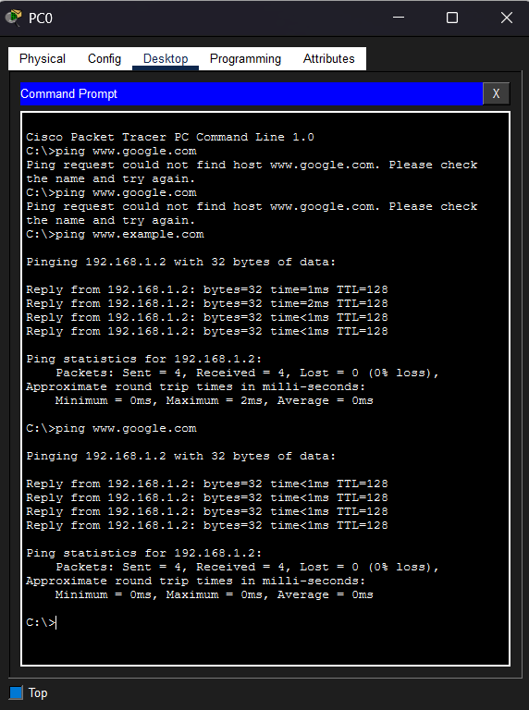
Task B:

DNS Testing and Analysis
• Perform:
o ping
o nslookup
o traceroute

• Analyze:
o Query time
o Response accuracy

• Name resolution process
